Stepper Motors
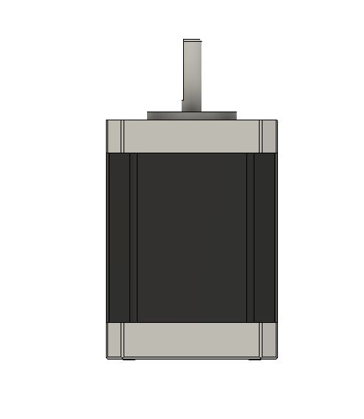

Let’s talk about stepper motors. What do you need to look for when selecting a motor?

What Size Stepper Motor Should You Use
The size of a stepper motor is just the footprint. It's the winding that will determine if your movement will work. There are Nema 17's that have more torque than 34's. A pancake model has less torque than a beefy long model. When moving a 3d printer bed up and down, the lead screw lifting it acts as a gear reduction and will increase torque. A small motor like a nema 17 can lift as much as a car with the right amount of gear reduction.

1.8 Degrees vs 0.9 Degrees
While many of the newer corexy designs are using 0.9 degree motors which helps the two motors remain in sync when moving in X and Y directions. The smaller torque dead zone from the 0.9 degree motors will help to reduce artifacts of the coreXY mechanism.

Nema Stepper Motor Dimensions
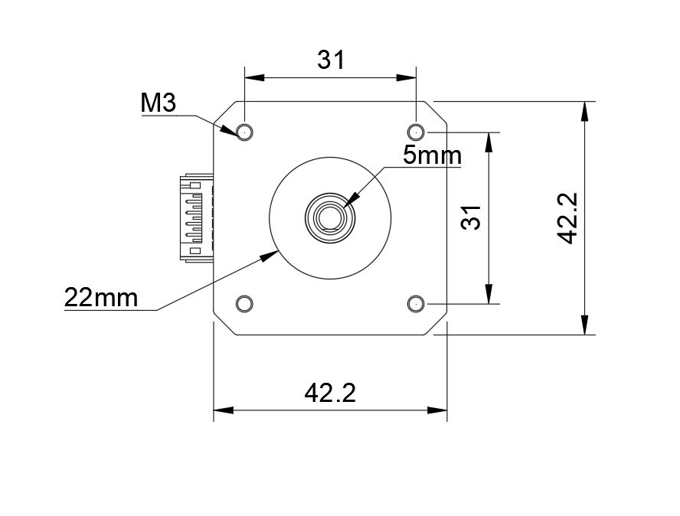

Nema Stepper Size
Nema17 Size 1.7 inches x 1.7 inches
Nema 23 Size 2.3 inches x 2.3 inches
Nema 34 Size 3.4 inches x 3.4 inches
Nema 42 Size 4.2 inches x 4.2 inches

Related Content

WorkHorse 3D Printer

Duet3D

Electronics

Stepper Motor Holding Torque

Electronics

Duet 3

Duet 3 Wiring Guide

Duet Wifi

RepRap Firmware

Docs

Stepper Motors

How To Calculate Stepper Motor RPM?

Stepper Motor Holding Torque

Unipolar vs Bipolar Stepper Motors

EndStops

0.9 vs 1.8 degrees Stepper Motors

WorkHorse-3D Printer Wiring

Set Macro Explained

Dual X-Axis / Dual Z

